


Database Management Lab Experiment (ENCS205)

Bachelor of Technology in
Computer Science and Engineering

Submitted by
Sahdev Sharma (2401010092)
B. Tech CSE (Core) – 4th Semester Section: A

Submitted To:
MS. Mansi Kajal

School of Engineering & Technology
K. R. MANGALAM UNIVERSITY
Sohna, Haryana 122103, India feb-2026

EXPERIMENT: 8

(Exercise on order by and group by clauses) Create Sales table with the following fields ( Sales No, Salesname, Branch, Salesamount, DOB).
( a ) Insert five records .
( b ) Calculate total salesamount in each branch .
( c ) Calculate average salesamount in each branch .
( d ) Display all the salesmen, DOB who are born in the month of December as day in character format i.e. 21-Dec-09.
( e ) Display the name and DOB of salesman in alphabetical order of the month .

[QUERY]:
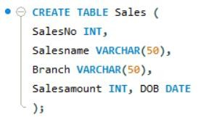

( a ) Insert five records .
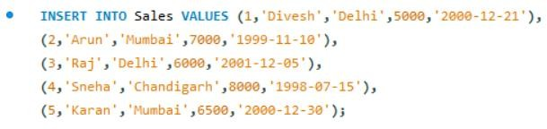

( b ) Calculate total sales amount in each branch .
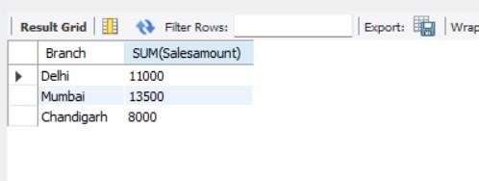

( c ) Calculate average sales amount in each branch .
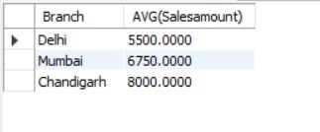

( d ) Display all the salesmen, DOB who are born in the month of December as day in character format i.e. 21-Dec-09.

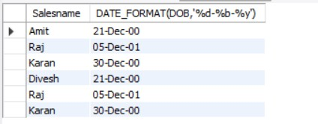

( e ) Display the name and DOB of salesman in alphabetical order of the month .
